Name: vyshnav suresh
Roll No: 56
Batch: B
Date: 21/04/2022

NETWORKING & SYSTEM ADMINISTRATION LAB

Experiment No.: 6

Aim
Familiarization of the linux commands.

Procedure
1. read
This command is used to read the content of a line to a variable.
Syntax :- $ read
Output :-
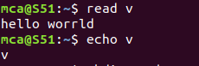

2. locate
This command is used to locate a file/particular directory.
Syntax :- $ locate filename.txt
Output :-
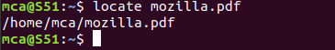

3. locate -i
This command is used to ingore case sensitivity of the specified pattern.
Syntax :- $ locate -i filename.txt
Output :-

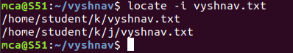

4. find
This command is used to display contents of particular directory.
Syntax :- $ find filename.txt
Output :-
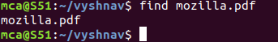

5. grep
This command will let you search through all the text in a given file.
Syntax :- $ grep word filename.txt
Output:-

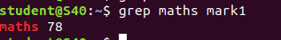
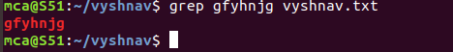

grep -i
command used for a case insensitive search
Syntax: $ grep -i filename.txt
Output:
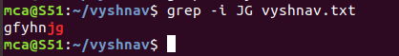

grep -v
command used for inverted search.
Syntax: $ grep -v filename.txt
Output:
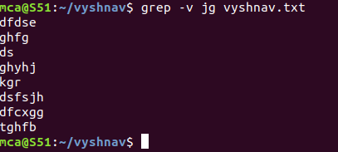

grep -A1
command used to display line after the result.
Syntax: $ grep -A1 filename.txt
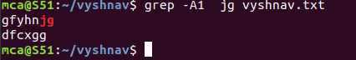
Output:

grep -B1
command used to display line before the result.
Syntax: $ grep -B1 filename.txt
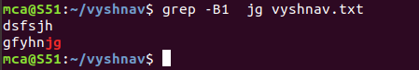
Output:

grep -C1
command used to display line before and after the result.
Syntax: $ grep -C1 filename.txt
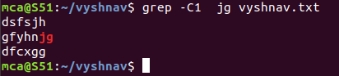
Output:

6. def
This command is used to get a report on system disc space usage.

Syntax :- $ def filename.txt
Output :-

7. df -m
This command is used to see the report in mega bytes.
Syntax :- $ def -m filename.txt
Output :-
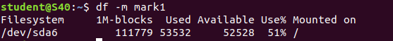

8. du
This command is used to check how space a file or directory takes
Syntax :- $ du filename.txt
Output :-
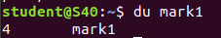

9. wc -word count
This command is used tfor counting purpose which is used to find the number of lines,the number of words,the number of characters and the number of bytes.

wc -l (count number of lines)
wc -w (count number of words)
wc -c (count number of characters)
wc -m (count number of bytes)

Syntax :- $ wc -l filename.txt
$ wc -w filename.txt
$ wc -c filename.txt
$ wc -m filename.txt

Output :-

